UNITED STATES

SECURITIES AND EXCHANGE COMMISSION
Washington, D.C. 20549

SCHEDULE 14A INFORMATION

Proxy Statement Pursuant to Section 14(a) of the

Securities Exchange Act of 1934
(Amendment No. )

Filed by the Registrant ☒ Filed by a Party other than the Registrant ☐

Check the appropriate box:

- Preliminary Proxy Statement

- Confidential, for Use of the Commission Only (as permitted by Rule 14a-6(e)(2))

- Definitive Proxy Statement

- Definitive Additional Materials

- Soliciting Material under Rule 14a-12

THE BABCOCK & WILCOX COMPANY

(Name of registrant as specified in its charter)

(Name of person(s) filing proxy statement, if other than the registrant)

Payment of Filing Fee (Check the appropriate box):

- No fee required.

- Fee computed on table below per Exchange Act Rules 14a-6(i)(4) and 0-11.

  - Title of each class of securities to which transaction applies:

  - Aggregate number of securities to which transaction applies:

  - Per unit price or other underlying value of transaction computed pursuant to Exchange Act Rule 0-11 (set forth the amount on which the filing fee is calculated and state how it was determined):

  - Proposed maximum aggregate value of transaction:

  - Total fee paid:

- Fee paid previously with preliminary materials.

- Check box if any part of the fee is offset as provided by Exchange Act Rule 0-11(a)(2) and identify the filing for which the offsetting fee was paid previously. Identify the previous filing by registration statement number, or the Form or Schedule and the date of its filing.

  - Amount Previously Paid:

  - Form, Schedule or Registration Statement No.:

  - Filing Party:

  - Date Filed:

EXPLANATORY NOTE

The following materials supplement the Definitive Proxy Statement filed by The Babcock & Wilcox Company (the “Company”) with the Securities and Exchange Commission on March 20, 2015. Beginning on April 20, 2015, these materials are being provided to certain stockholders of the Company in connection with the solicitation of proxies for the Company’s 2015 Annual Meeting of Stockholders to be held on May 1, 2015.

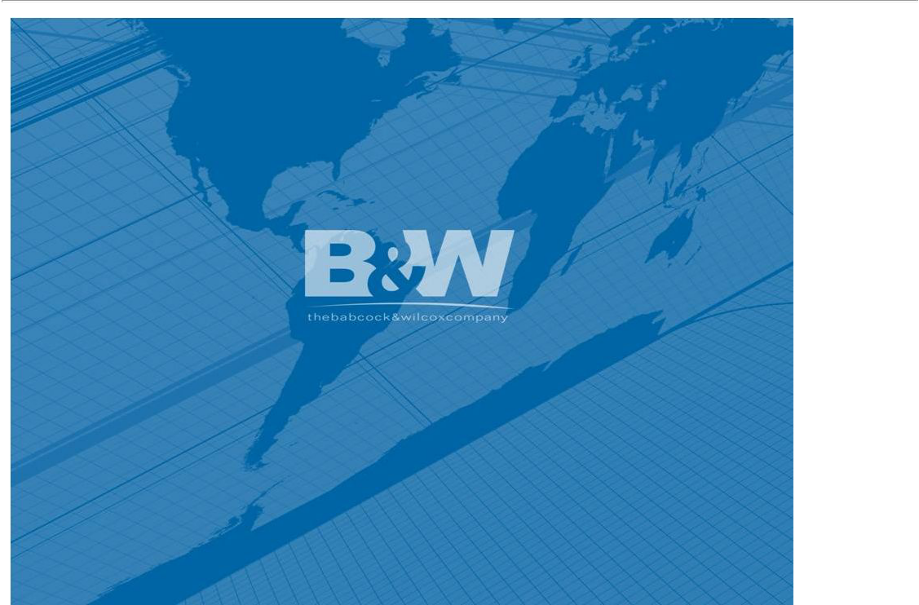

Shareholder Outreach

2015 Proxy Season

- April 2015

© 2015 Babcock & Wilcox Company. All Rights Reserved.

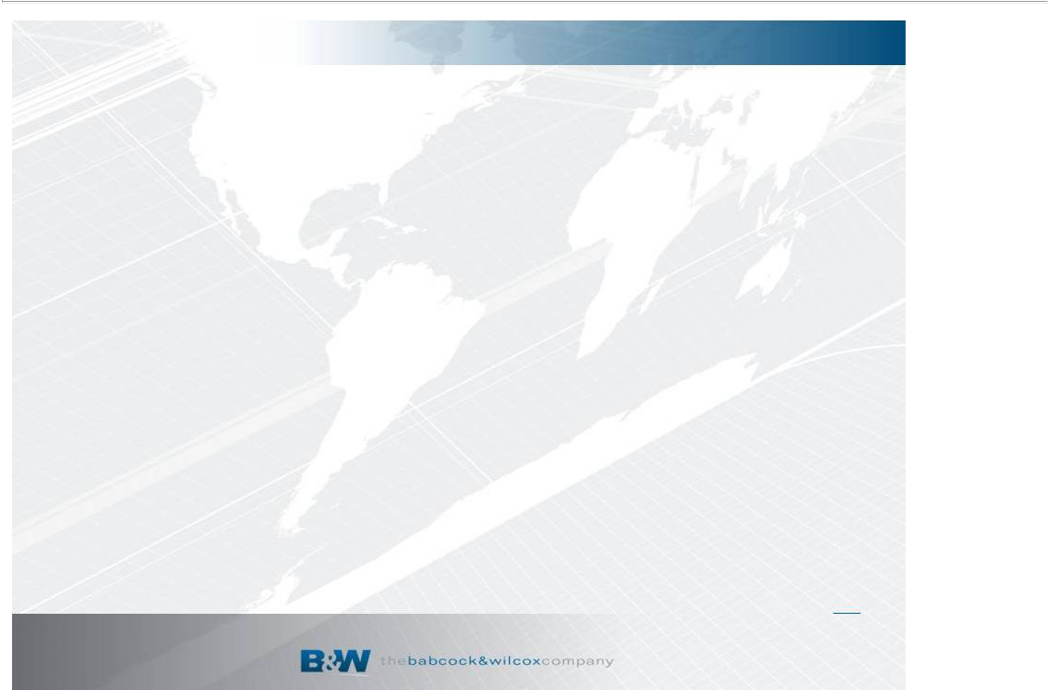
Safe Harbor

B&W cautions that this presentation contains forward-looking statements within the meaning of the safe harbor provisions of the U.S. Private Securities Litigation Reform Act of 1995 and Section 21E of the Securities Exchange Act of 1934, including, without limitation, statements relating to the manner, timing, tax-free nature and expected benefits associated with separating B&W’s power generation business and its government and nuclear operations business into two independent,publicly traded companies, as well as the anticipated management teams

and 2015 revenue projections of the separated companies and their ability to create value for their respective shareholders. These forward-looking statements are based on management’s current expectations and involve a number of risks and uncertainties, including, among other things, the proposed spin-off may not be completed as anticipated or at all, delays or other difficulties in completing the spin-off, including the inability to satisfy the conditions for completing the spin-off, disruptions experienced with customers and suppliers, the inability of either businessto successfullyoperateindependentlyandthe inabilityto retainkey personnelIf. oneor moreof theserisksor otherrisks

materialize, actual results may vary materially from those expressed. For a more complete discussion of these and other risk factors, see B&W’s filings with the Securities and Exchange Commission,itsincludingannualreport on Form 10-K for the year ended December 31, 2014

and the Form 10 filing of Babcock & Wilcox Enterprises, Inc. B&W cautions not to place undue reliance on these forward-looking statements, which speak only as of the date of this presentation, and undertakes no obligation to update or revise any forward-looking statement, except to the extent required by applicable law.

2

© 2015 Babcock & Wilcox Company. All Rights Reserved.

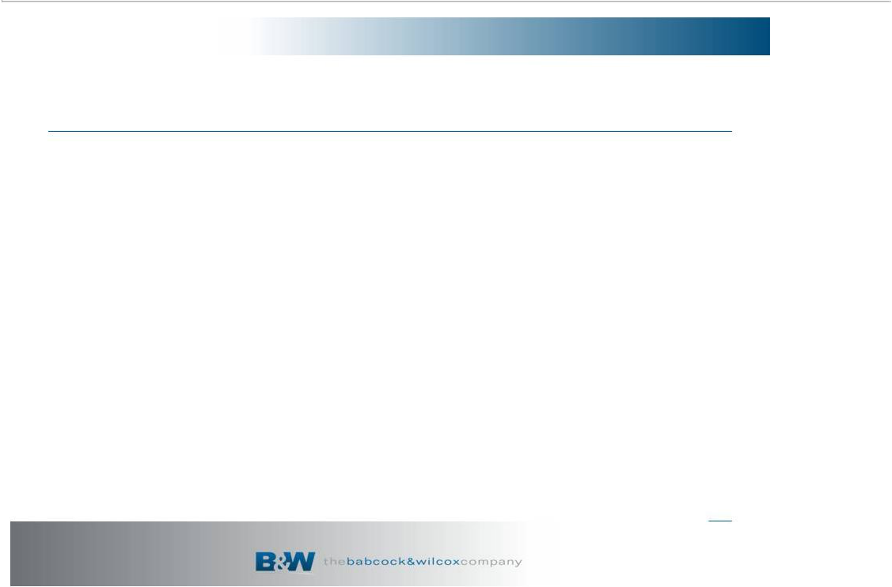
Executive Summary

- B&W: A History of Innovation in Energy Technology and Services

- Sound Operating Performance and Shareholder Value Creation

- 2015 Transition: Spin-Off of the Power Generation Business

- Compensation Structure Linking Pay and Performance While Driving Shareholder Value

- Executive Compensation Governance in Shareholders’ Interests

- Highly Qualified, Independent Board and Sound Governance

3

© 2015 Babcock & Wilcox Company. All Rights Reserved.

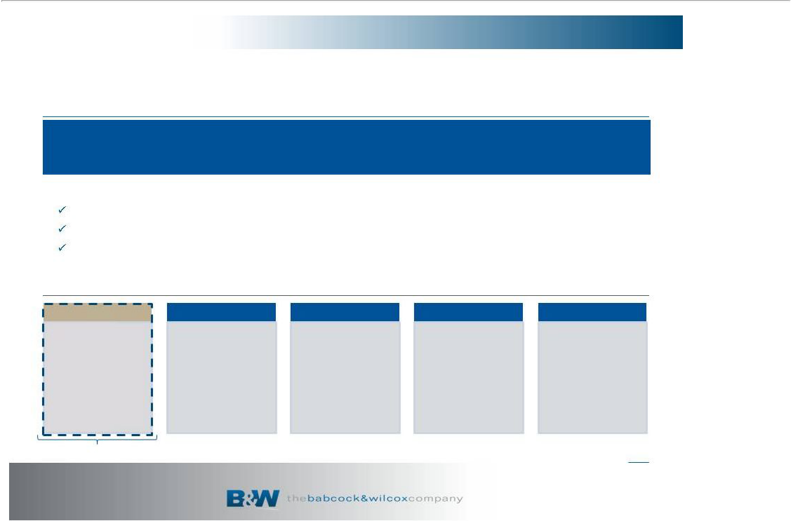
B&W: A History of Innovation in Energy Technology and Services

The Babcock & Wilcox Co. is a leader in clean energy technology and services, primarily for the nuclear, fossil and renewable power markets, as well as an advanced technology and mission critical defense contractor

BWC is a preferred global leader, excelling in the delivery of advanced energy and operational solutions by:

Delivering innovative technologies and solutions to fulfill the needs of our customers.

Providing a challenging, rewarding, and safe work environment for our employees.

Generating increasing value for our stakeholders.

 | We Operate Across 5 Segments
Power Generation | Nuclear Energy | Nuclear Operations | Technical Services | mPower
• Environmental / | • Nuclear component | • Virginia-Class submarine | • Safe nuclear operations | • Small modular reactor
emissions control | design, manufacture and | program | management | (SMR) design
systems | installation | • Ford-Class carrier | • Secure nuclear material
• Fossil fuel-fired power | • Component inspection, | program | handling, storage and
generation | maintenance and repair | • Refueling | waste management
• Service, operation and | • Design services | • Fuel processing and | • Leadership of high-
maintenance | • Specialized tooling | fabrication | consequence, nuclear
• Renewable power | design | • HEU downblending | laboratories
generation
• Industrial environmental
equipment / solutions

Being spun-out in 2015

4

© 2015 Babcock & Wilcox Company. All Rights Reserved.

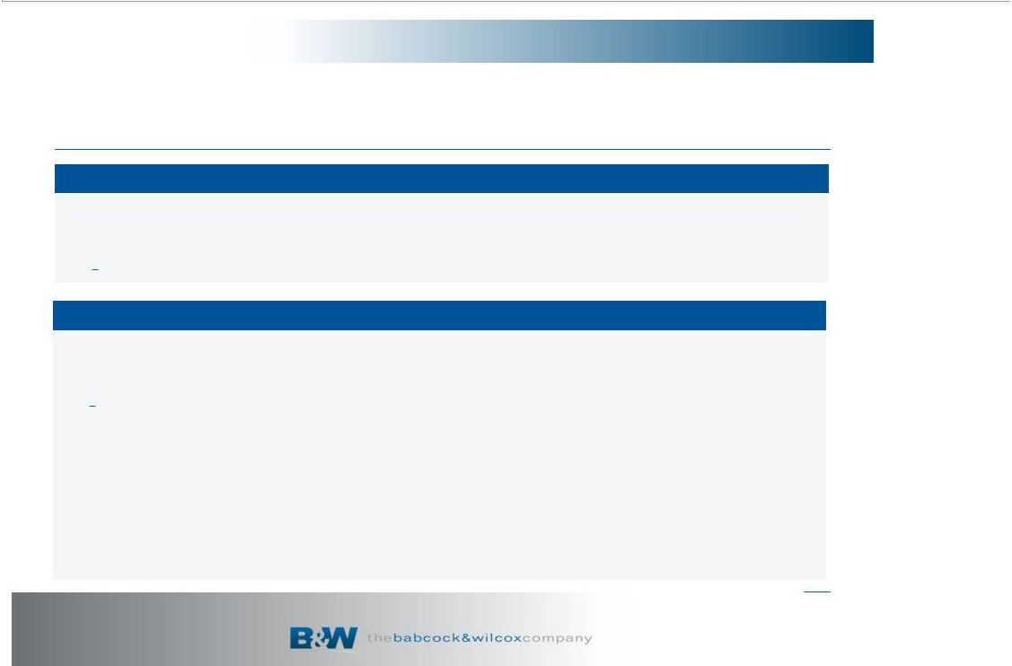
Focus on Improving Operating Performance and Transforming Long-Term Strategy in a Challenging Market Environment

2014 Business and Financial Highlights

- Nuclear Operations Group segment continued to have strong performance, setting records for revenue and operating income

- Challenging Commercial Market Environment

Low natural gas price and increasing regulatory pressure created headwinds for both nuclear and coal units

Long-Term Strategic Transformation Underway

- Restructured mPower (small modular reactor program) to significantly reduce spending

- Global Competitiveness Initiative (GCI) designed to enhance B&W’s core competitiveness by reducing complexity, improving efficiency, and aligning operations and structure with competitive landscape

Close to achieving total annual savings of approximately $75 million

- Restructure the Nuclear Energy segment by exiting projects business and reducing headcount and manufacturing footprint

- Margin improvement program targeting 200 – 300bp improvement in operating margin for PGG

- Created a global sales organization to drive international growth of new renewable waste to energy and coal plant sales

- Acquired MEGTEC to create new growth opportunity in an adjacent market for industrial environmental controls

- Decision to spin-off Power Generation business

5

© 2015 Babcock & Wilcox Company. All Rights Reserved.

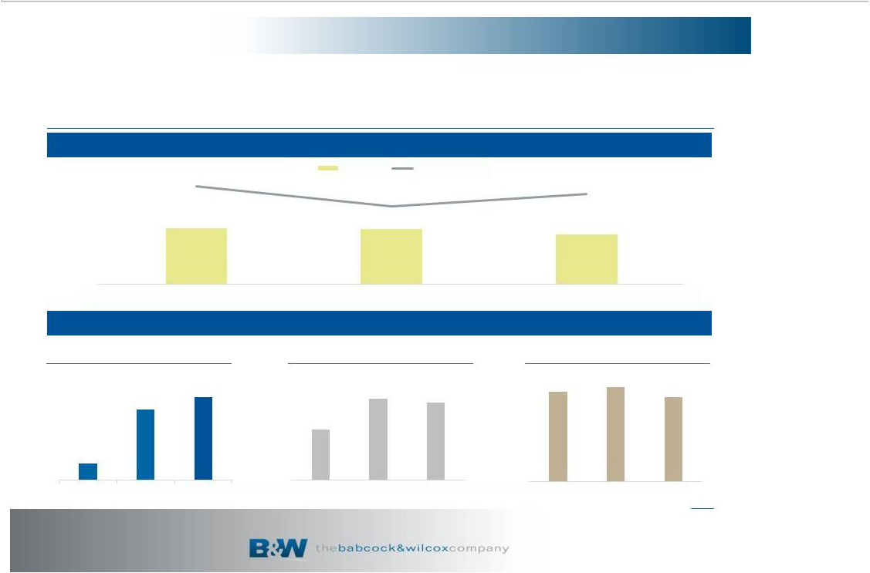
Shareholder Value Creation in Challenging Market

Growth in Backlog Will Catalyze Revenue Growth in 2015

($ in thousands) | $5,749 | Revenues | Backlog
 | $5,749 |  | $5,292
 |  | $4,590
 | $3,291 | $3,269 | $2,923

2012 2013 2014

Delivering Value to Shareholders Through Dividends and Share Repurchases

 |  |  |  |  |  | Adj. EPS Attributed
Dividends Per Share |  |  | Share Repurchases ($M) |  |  | to B&W, Diluted¹
 |  | $0.40 |  |  |  | $2.17 | $2.27 | $2.03
 |  | $0.40 |  | $157.1 |  | $2.17 |  | $2.03
 | $0.34 | $0.40 |  | $157.1 | $149.8 |  |  | $2.03
 |  |  | $96.8
$0.08
2012 | 2013 | 2014 | 2012 | 2013 | 2014 | 2012 | 2013 | 2014

- See appendix for Reconciliation of Non-GAAP EPS

6

© 2015 Babcock & Wilcox Company. All Rights Reserved.

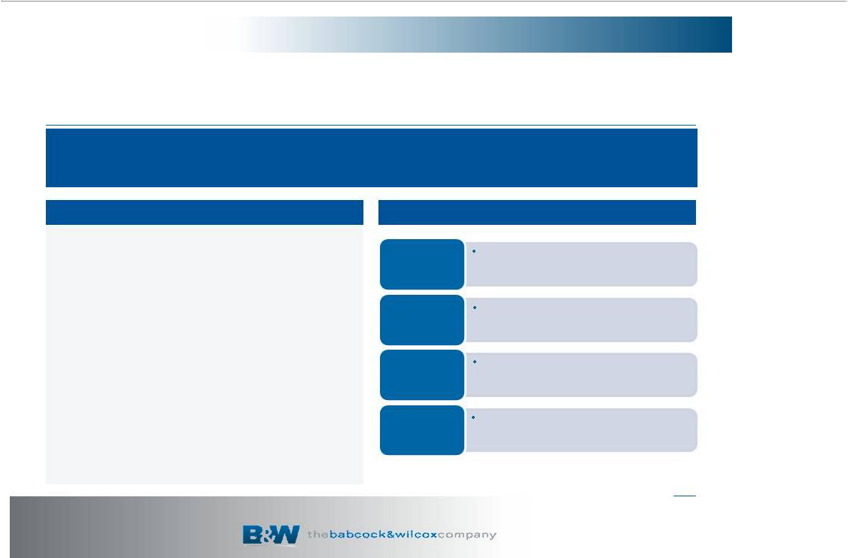
Driving Shareholder Value Through the Spin-Off

Tax-free spin-off of the Company’s Power Generation business to B&W’s shareholders is expected to be completed in mid-2015

Plans to Spin-Off Power Generation Business

- In November 2014, B&W announced plans to spin-off the company’s Power Generation business

- Tax-free spin-off to B&W shareholders

- Post-transaction, shareholders will own 100% of two independent, publicly traded companies:

– BWX Technologies, Inc. (“BWXT”concurrent with the spin-off will be renamed from “The Babcock & Wilcox Company”)

– Babcock & Wilcox Enterprises, Inc. (currently Power Generation Group)

Strategic Benefits of Spin-Off

Efficient | Flexibility to deploy and execute a focused
Capital | capital structure consistent with the
Allocation | strategic priorities of each business
Independent | Increased opportunities to pursue external
Strategies | growth strategies as independent
 | companies
Equity Market | Ability to attract an investor base suited to
Alignment | the particular operational and financial
 | characteristics of each company
Focused | Greater management focus on the distinct
Management | businesses of Power Generation and
 | Government & Nuclear Operations

7

© 2015 Babcock & Wilcox Company. All Rights Reserved.

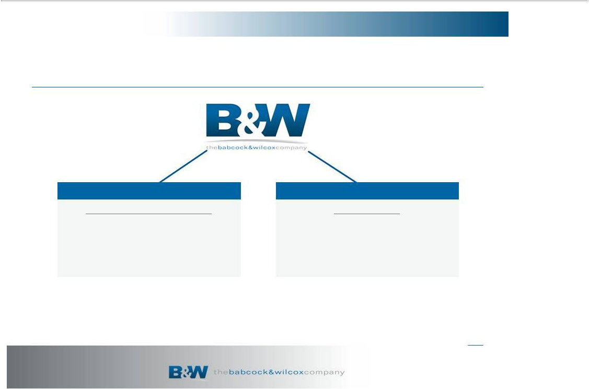
Two Publicly Traded Companies in Mid-2015

BWX Technologies, Inc. |  | Babcock & Wilcox Enterprises, Inc.
Government & Nuclear Operations |  | Power Generation
Headquarters: | Lynchburg, VA | Headquarters: | Charlotte, NC
Incorporation: | Delaware | Incorporation: | Delaware
Executive Chairman: | John A. Fees | Chairman & CEO: | E. James Ferland
CEO: | Peyton S. Baker
Projected 2015 revenue: | $1.4B | Projected 2015 revenue: | $1.7B
# of Employees: | ~5,300 | # of Employees: | ~5,700

8

© 2015 Babcock & Wilcox Company. All Rights Reserved.

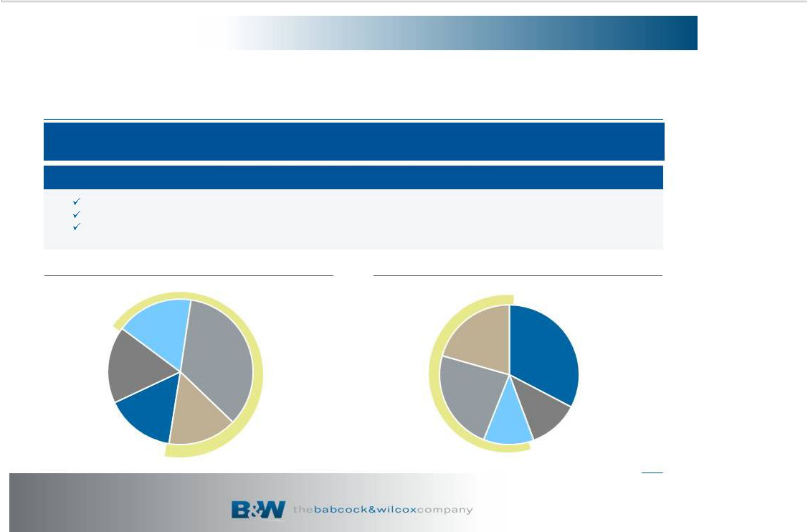
Executive Compensation Program Puts Majority of Pay at Risk

B&W seeks to provide reasonable and competitive compensation

within a “pay-for-performance” framework

Compensation program is designed to:

Incent and reward annual-and long-term performance

Align interests of B&W executives with shareholders

Attract and retain well-qualified executives

2014 CEO Target Total Direct Compensation

 | 68% of CEO Pay is
 | Performance Based
Options 17%
 | Performance
RSUs 17% | RSUs 35%

2014 All Other NEOs Total Direct Compensation

Annual

Incentive 21% Base Salary

33%

Base Salary Annual

16% Incentive 15%

Performance

RSUs 23%

Options

56% of NEO Pay is ^{12%}

Performance Based

RSUs

12%

9

© 2015 Babcock & Wilcox Company. All Rights Reserved.

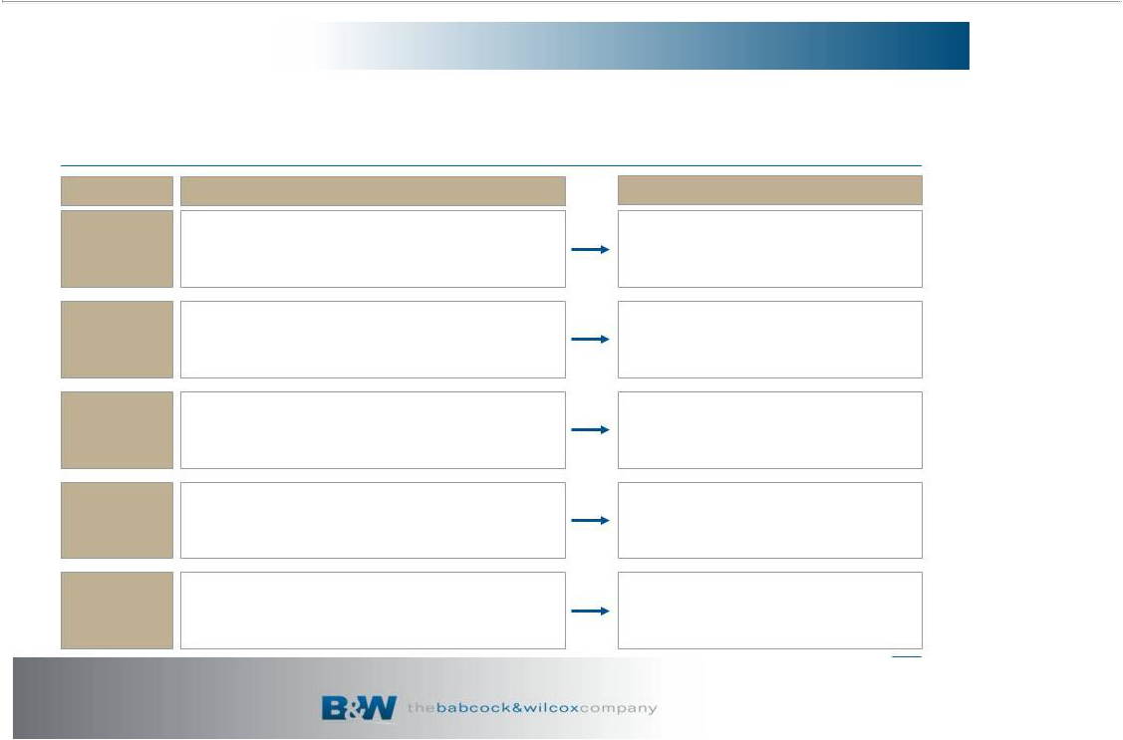
2014 Elements of Executive Compensation Program

Element Description / Characteristics

Primary Objectives

Base Salary

Annual

Incentive

Long-Term Incentive

Retirement

Benefits

Other Benefits

- Annual fixed cash compensation

- Cash-based compensation

- Based on a mix of financial, safety and individual goals

- 100% performance-based

- Long-term (typically 3 years) stock-based compensation

- Mix of performance-based awards (performance restricted stock units and stock options) and time-based awards (restricted stock units)

- Defined benefit pension plan (closed to new participants in 2006; benefits to be frozen 12/31/15)

- 401(k) plans

- Supplemental Executive Retirement Plan

- Financial planning and executive physical

- Company-subsidized medical; employee-paid dental, vision, disability and life insurance

- Change-in-control agreements and severance plan

- Attract and retain qualified talent

- Incent/reward annual performance

- Incent/reward long-term performance

- Align interest of executive with stockholders via opportunities to build stock ownership

- Provide means for participants to build retirement savings over long B&W careers

- Promote productivity and well being

10

© 2015 Babcock & Wilcox Company. All Rights Reserved.

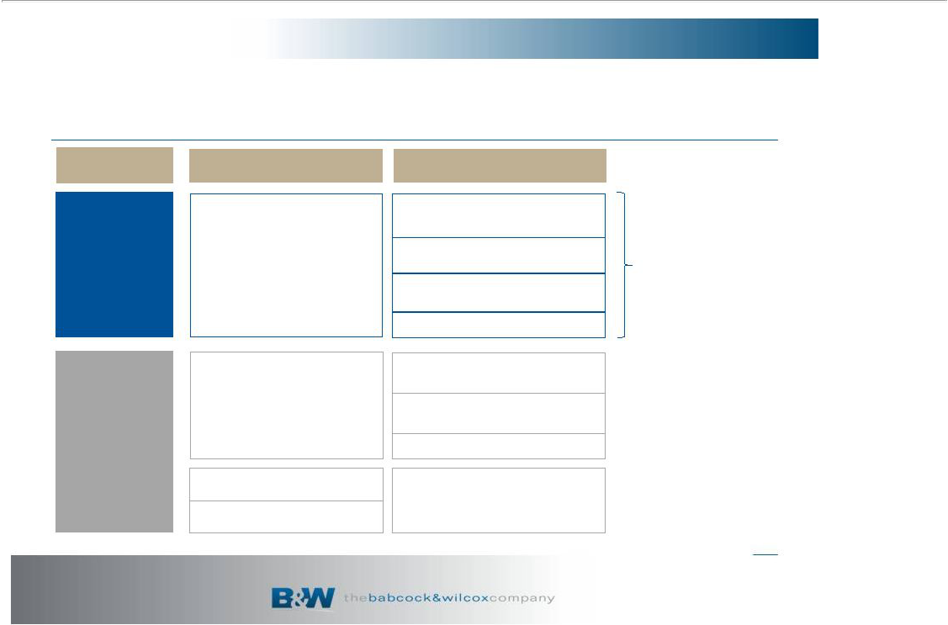
2014 Incentive Plan Structure Links Executive Compensation to Financial and Stock Performance

Pay Element Components

Annual
Incentive ^{Cash}

Performance Link

Operating Income

(45% weighting)

Annual ROIC

(25%)

Individual (20%)

Safety Performance (10%)

Pre-Set Measurable Goals

Three-Year Average ROIC

(40%)

If Operating Income is

not achieved at

threshold performance,

no bonus plan is paid

Long-Term

Equity Based

Incentives

Performance-Based RSUs

(50%)

RSUs (25%)

Stock Options (25%)

Cumulative EPS (40%)

3-Year Relative TSR (20%)

Long-Term Stock

Performance

11

© 2015 Babcock & Wilcox Company. All Rights Reserved.

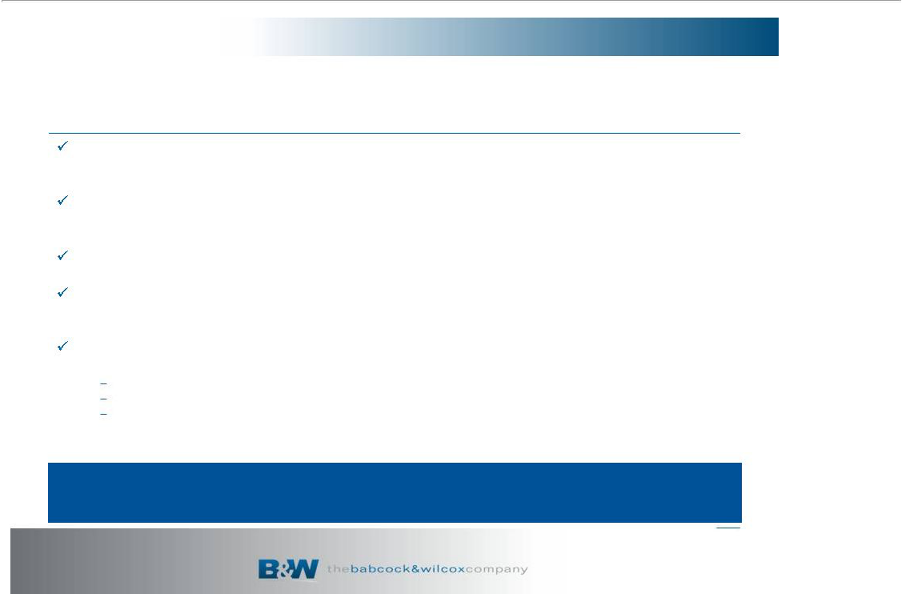
2014 Pay Outcomes Demonstrate Alignment with Performance

CEO’s 2012-14 long-term performance share grant did not vest after three-year performance period ended 2014 when performance targets were not achieved

CEO’s 4-year vesting restricted stock, one-time sign-on grant (granted in 2012) is tracking in line with company’s lower stock price through 2014

Annual bonus pool does not fund if threshold financial metric (operating income) is not achieved

Board has authority to apply negative discretion to the annual bonus program within 162m framework, and has used it historically including in 2014

Performance targets were selected and set at challenging levels through rigorous process to reflect rapidly changing markets and company transformation

Bottoms up process that starts with management teams

Top down review by senior management and Board to create challenging targets

Process is aligned and benchmarked with peer group plan structure

2012-14 Long-Term Equity Grants Paid Out at Zero After Missing 3-Year Performance Targets on Average ROIC and Cumulative Adjusted EPS

12

© 2015 Babcock & Wilcox Company. All Rights Reserved.

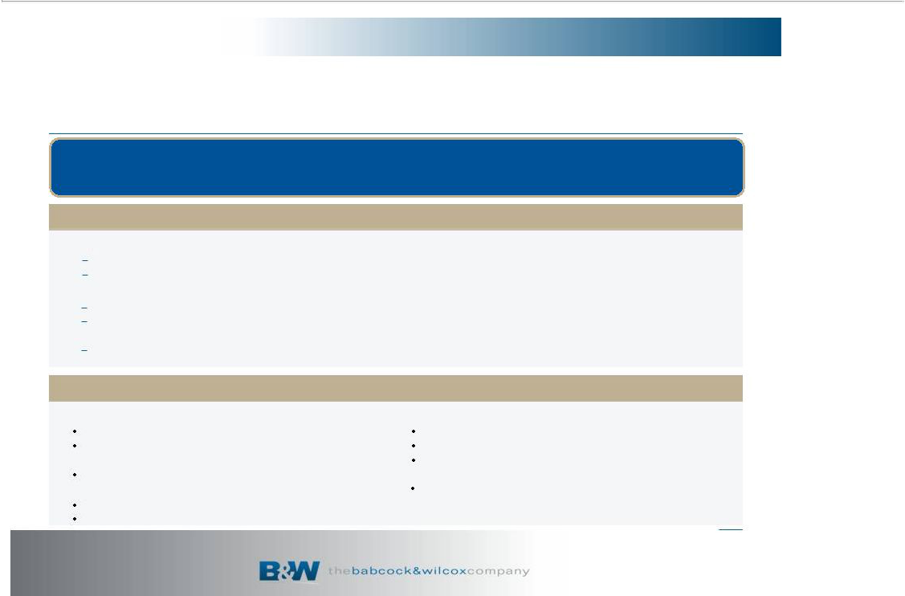
Thorough Process for Setting Compensation that Reflects Challenging Metrics and Rapidly Changing Market

Compensation Levels are Benchmarked to Reasonably Sized Peers in Relevant Industries;

Significantly Larger Peers Are Used for Benchmarking Pay Practices,

And Not For Setting Pay Levels

Approach to Setting Executive Compensation

- Compensation Value – Broad Peer Group of 300 industrial companies

Total direct compensation for NEOs targeted at median of a broadsurvey of over 300 general industrial companies Data is adjusted using regression analysis based on revenues to account for company size

- Compensation Structure – Custom Peer Group of 16 Companies

Supports decisions around pay design and metrics

Includes companies where we compete for talent in the engineering and construction, aerospace and defense, heavy

electrical equipment and industrial machinery industries
Reviewed peer group for 2014; two companies were removed due to higher revenue and/or market cap

Why We Choose Financial Metrics

Operating Income

Overall profitability of enterprise Aligned with share price movement

Return on Invested Capital

Maximum utilization of company assets
Cumulative Earnings per Share

Commonly used performance metric Correlation to stock price

Total Shareholder Return

Prevalent performance measure

Increases alignment with shareholders

Responsive to shareholder input on metric selection

Metrics Benchmarked to Industry Peers

Metrics and process for setting goals are benchmarked against peer group practices

13

© 2015 Babcock & Wilcox Company. All Rights Reserved.

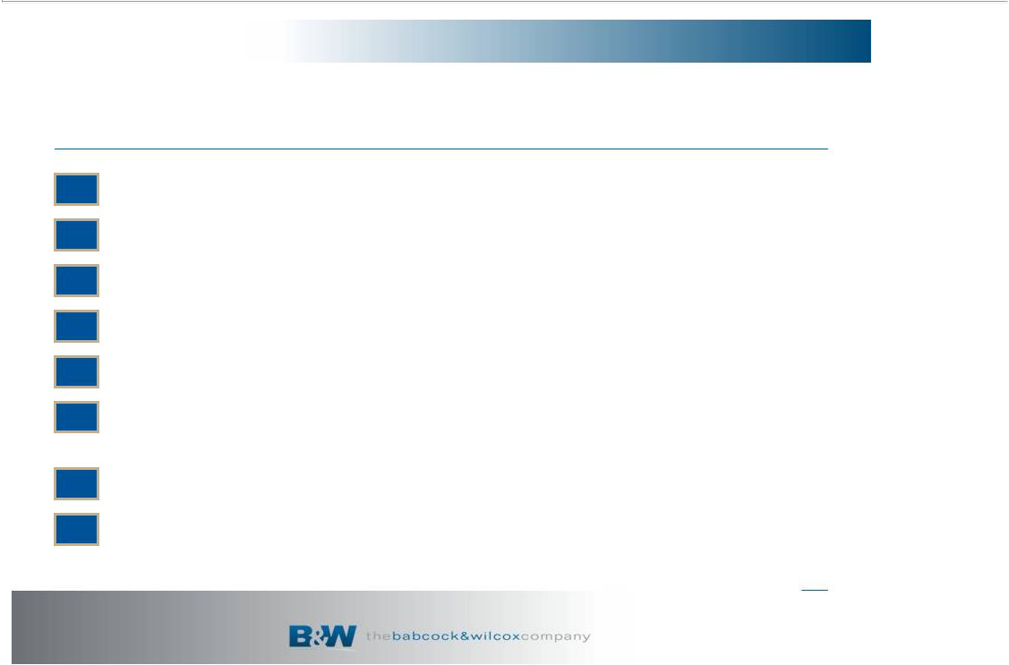
Executive Compensation Governance in Shareholders’ Interests

- Align pay with performance

- Strong stock ownership guidelines (5x base salary for CEO)

- Limited perquisites, each with direct business purpose

- Clawback provisions in annual and long-term incentive compensation

- Robust anti-hedging and pledging provisions

- Double-trigger change-in-control severance arrangements for executives; with exception for broad-based employee stock program

- No tax gross-ups on change-in-control benefits

- Fully independent compensation committee and compensation consultant

14

© 2015 Babcock & Wilcox Company. All Rights Reserved.

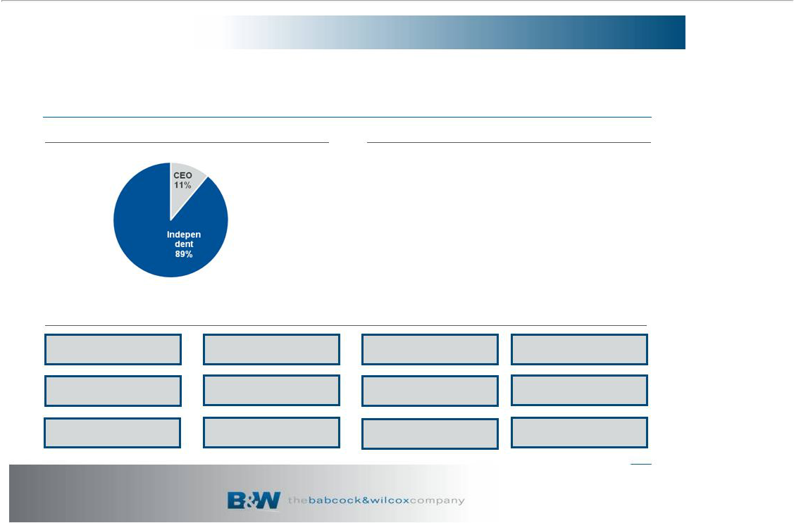
Highly Qualified, Independent Board and Sound Governance

Majority of Board Independent | Key Governance Attributes
1. | Focus on Board renewal, 3 new Directors over the past
 | two years bringing fresh perspective to the boardroom
2. | Strong Lead Independent Director provides additional
 | independent oversight through a range of responsibilities
3. | All directors own stock in accordance with our ownership
 | guidelines (5x annual base retainer)
4. | Majority voting policy for the election of directors increases
 | accountability to shareholders

Directors Have Powerful Combined Skill Set

M&A | Nuclear Power / Fossil | Engineering | Multinational
M&A | Fuel Generation | Engineering | Operations
Corporate Governance | Manufacturing | Former CEOs & CFOs | Utility Generation
Legal | Audit | Corporate Strategy | Government Sector
Legal | Audit | Corporate Strategy | Experience

15

© 2015 Babcock & Wilcox Company. All Rights Reserved.

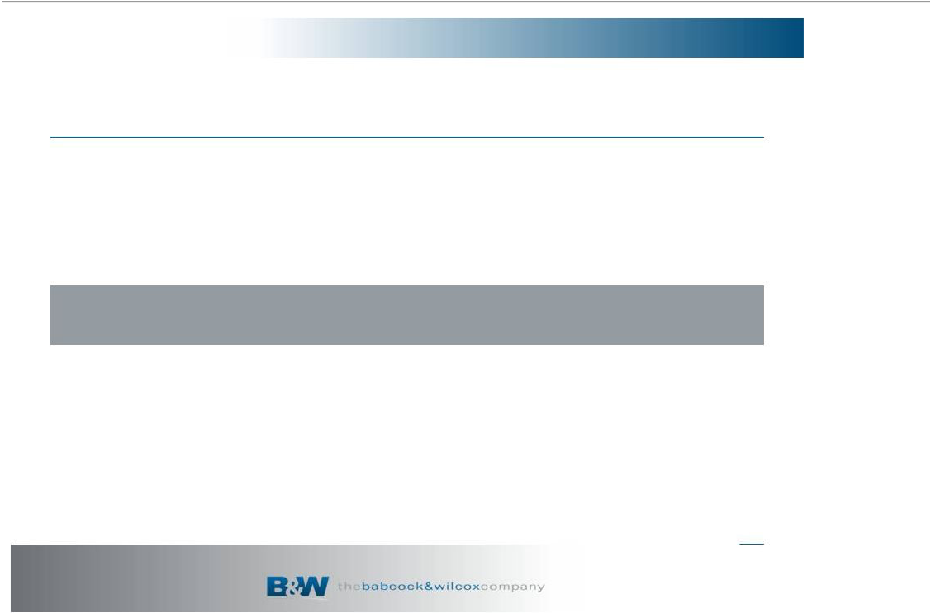

Appendix

© 2015 Babcock & Wilcox Company. All Rights Reserved.

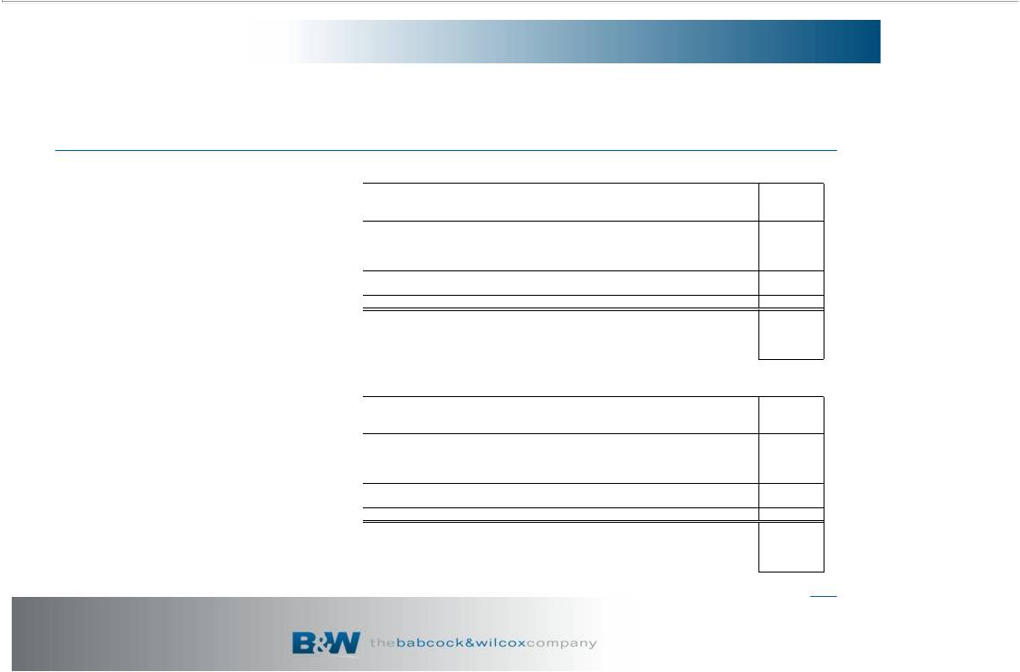
Reconciliation of Non-GAAP EPS and Operating Income

 |  |  |  |  | Twelve Months Ended December 31, 2014
 |  |  |  |  |  | Centrus |  |  | Pension & |  | Restructuring
 |  |  |  |  |  | Gain, net |  |  | OPEB MTM |  |  |  | &
 |  | GAAP | Spin Costs |  | Impairment |  |  | Litigation | (Gain) / Loss |  |  | Acquisitions |  | Non-GAAP
Operating Income | $ | (2.6) | $ | 6.1 | $ | - | $ | 16.1 | $ | 241.2 |  | $ | 57.7 | $ | 318.4
Other Income / (Expense) |  | 8.1 |  | - |  | (14.4) |  | - |  | 0.5 |  |  | - |  | (5.8)
Income Tax (Expense) / Benefit |  | 16.0 |  | (2.3) |  | - |  | (4.3) |  | (89.6) |  |  | (19.6) |  | (99.8)
Net Income (Loss) | $ | 21.5 | $ | 3.7 | $ | (14.4) | $ | 11.8 | $ | 152.1 |  | $ | 38.1 | $ | 212.8
Net Loss Attributable to Non-Controlling Interest |  | 7.9 |  | - |  | - |  | - |  | - |  |  | - |  | 7.9
Net Income (Loss) Attributable to The Babcock & Wilcox Company | $ | 29.4 | $ | 3.7 | $ | (14.4) | $ | 11.8 | $ | 152.1 |  | $ | 38.1 | $ | 220.7
Diluted Earnings per Common Share | $ | 0.27 | $ | 0.03 | $ | (0.13) | $ | 0.11 | $ | 1.40 |  | $ | 0.35 | $ | 2.03
Tax Rate |  | (292.6%) |  |  |  |  |  |  |  |  |  |  |  |  | 31.9%
 |  |  |  | Twelve Months Ended December 31, 2013
 |  |  | One-time tax |  |  |  |  |  | Pension & |  | Restructuring
 |  |  |  | (Benefit) / | Impairment |  |  |  | OPEB MTM |  |  |  | &
 |  | GAAP |  | Charges |  | Charges |  | Litigation | (Gain) / Loss |  |  | Acquisitions |  | Non-GAAP
Operating Income | $ | 536.4 | $ | - | $ | - | $ | - | $ | (222.7) |  | $ | 39.6 | $ | 353.2
Other Income / (Expense) |  | (19.2) |  | - |  | 19.1 |  | - |  | (0.2) |  |  | - |  | (0.2)
Income Tax (Expense) / Benefit |  | (184.6) |  | 6.3 |  | - |  | - |  | 80.4 |  |  | (13.2) |  | (111.1)
Net Income (Loss) | $ | 332.6 | $ | 6.3 | $ | 19.1 | $ | - | $ | (142.5) |  | $ | 26.4 |  | 241.9
Net Loss Attributable to Non-Controlling Interest |  | 13.5 |  | - |  | - |  | - |  | - |  |  | - |  | 13.5
Net Income (Loss) Attributable to The Babcock & Wilcox Company | $ | 346.1 | $ | 6.3 | $ | 19.1 | $ | - | $ | (142.5) |  | $ | 26.4 |  | 255.3
Diluted Earnings per Common Share | $ | 3.07 | $ | 0.06 | $ | 0.17 | $ | - | $ | (1.26) |  | $ | 0.23 | $ | 2.27
Tax Rate |  | 35.7% |  |  |  |  |  |  |  |  |  |  |  |  | 31.5%

*Note: May not foot due to rounding

17

© 2015 Babcock & Wilcox Company. All Rights Reserved.

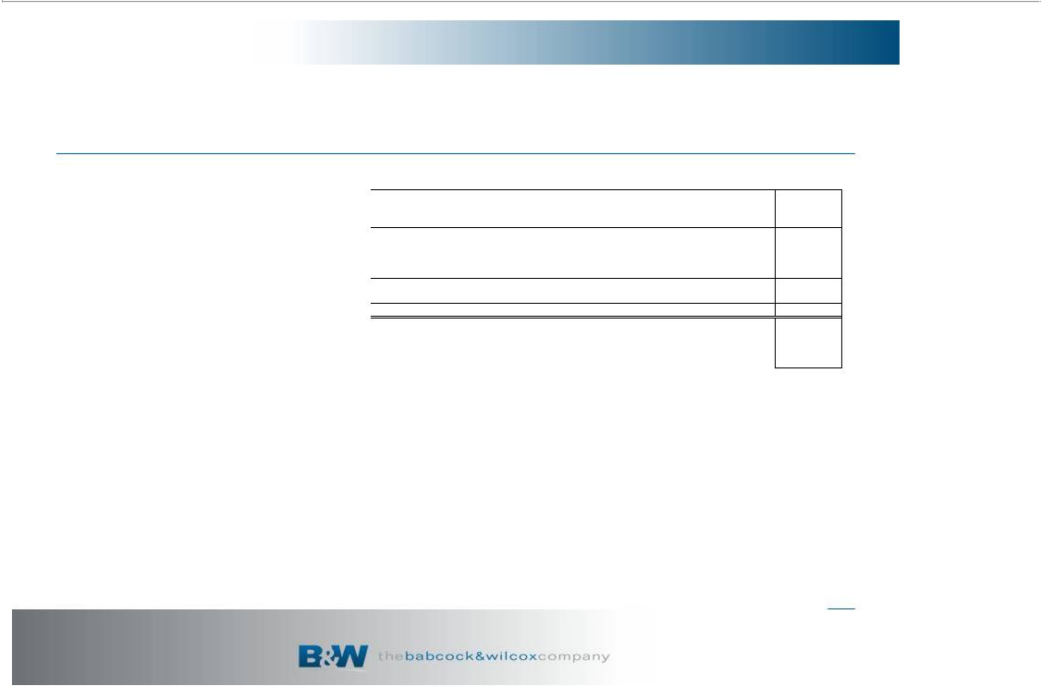
Reconciliation of Non-GAAP EPS and Operating Income (Cont’d)

 |  |  |  |  | Twelve Months Ended December 31, 2012
 |  |  | One-time tax |  |  |  |  |  | Pension & |  | Restructuring
 |  |  |  | (Benefit) / | Impairment |  |  |  | OPEB MTM |  |  | &
 |  | GAAP |  | Charges |  | Charges |  | Litigation | (Gain) / Loss Acquisitions |  |  |  | Non-GAAP
Operating Income (Loss) | $ | 346.6 | $ | - | $ | 2.6 | $ | - | $ | 31.9 | $ | - | $ | 381.1
Other Income / (Expense) |  | (27.2) |  | - |  | 27.0 |  | - |  | 0.2 |  | - |  | (0.0)
Provision for Income Taxes |  | (101.9) |  | (18.5) |  | (1.0) |  | - |  | (11.0) |  | - |  | (132.4)
Net Income (Loss) |  | 217.6 |  | (18.5) |  | 28.6 | $ | - |  | 21.1 |  | - |  | 248.7
Net Loss Attributable to Non-Controlling Interest |  | 10.1 |  | - |  | - |  | - |  | - |  | - |  | 10.1
Net Income Attributable to The Babcock & Wilcox Company | $ | 227.7 | $ | (18.5) | $ | 28.6 | $ | - | $ | 21.1 | $ | - | $ | 258.8
Diluted Earnings per Common Share | $ | 1.91 | $ | (0.16) | $ | 0.24 | $ | - | $ | 0.18 | $ | - | $ | 2.17
Tax Rate |  | 31.9% |  | n/a |  | 3.4% |  |  |  | 34.3% |  |  |  | 34.7%

*Note: May not foot due to rounding

18

© 2015 Babcock & Wilcox Company. All Rights Reserved.

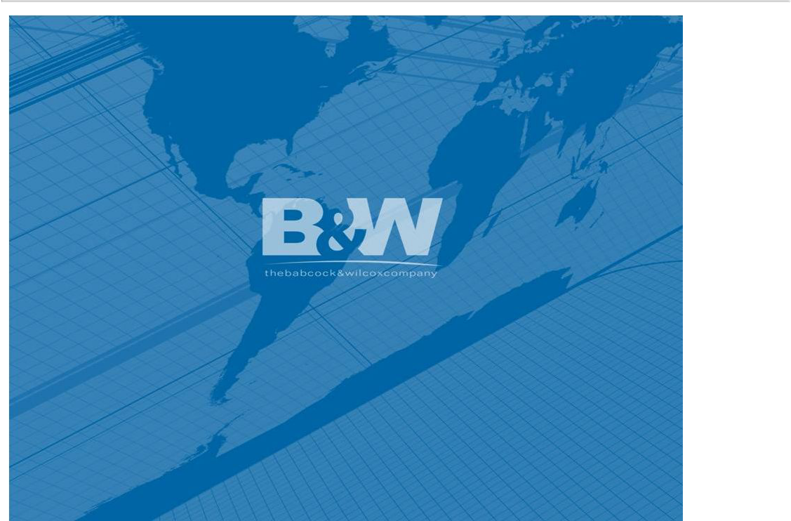
Please reach out with any questions

Jenny Apker

VP Treasury & Investor Relations

Office: 704.625.4937

Email: jlapker@babcock.com

© 2015 Babcock & Wilcox Company. All Rights Reserved.

